**Libary Book Search Plugin**

Please check steps to install and setup the plugin:

1) You can install it from the plugins page of the wordpress back-end.  
  
2) You can import xml file which i have provided on the folder using Tools->import to import some dummy book posts and check search & listing.

3) Setting page:

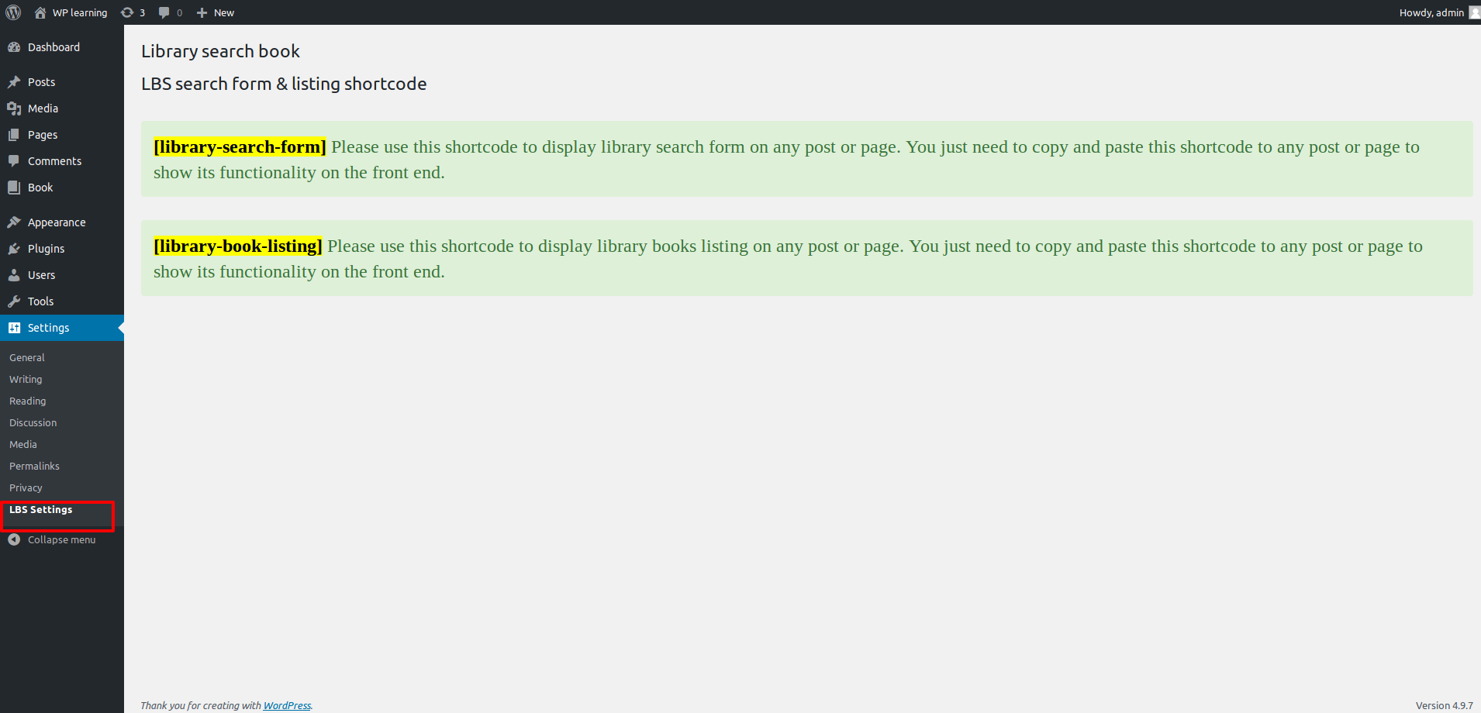

Backend-CPT page:

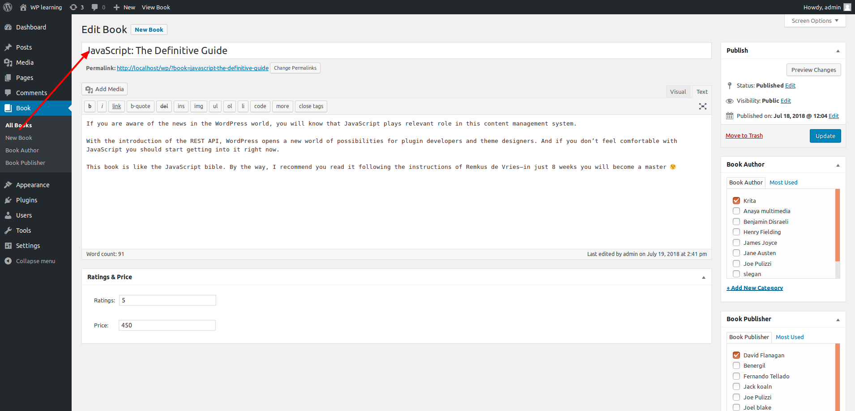

4) Front page with both the shortcodes:

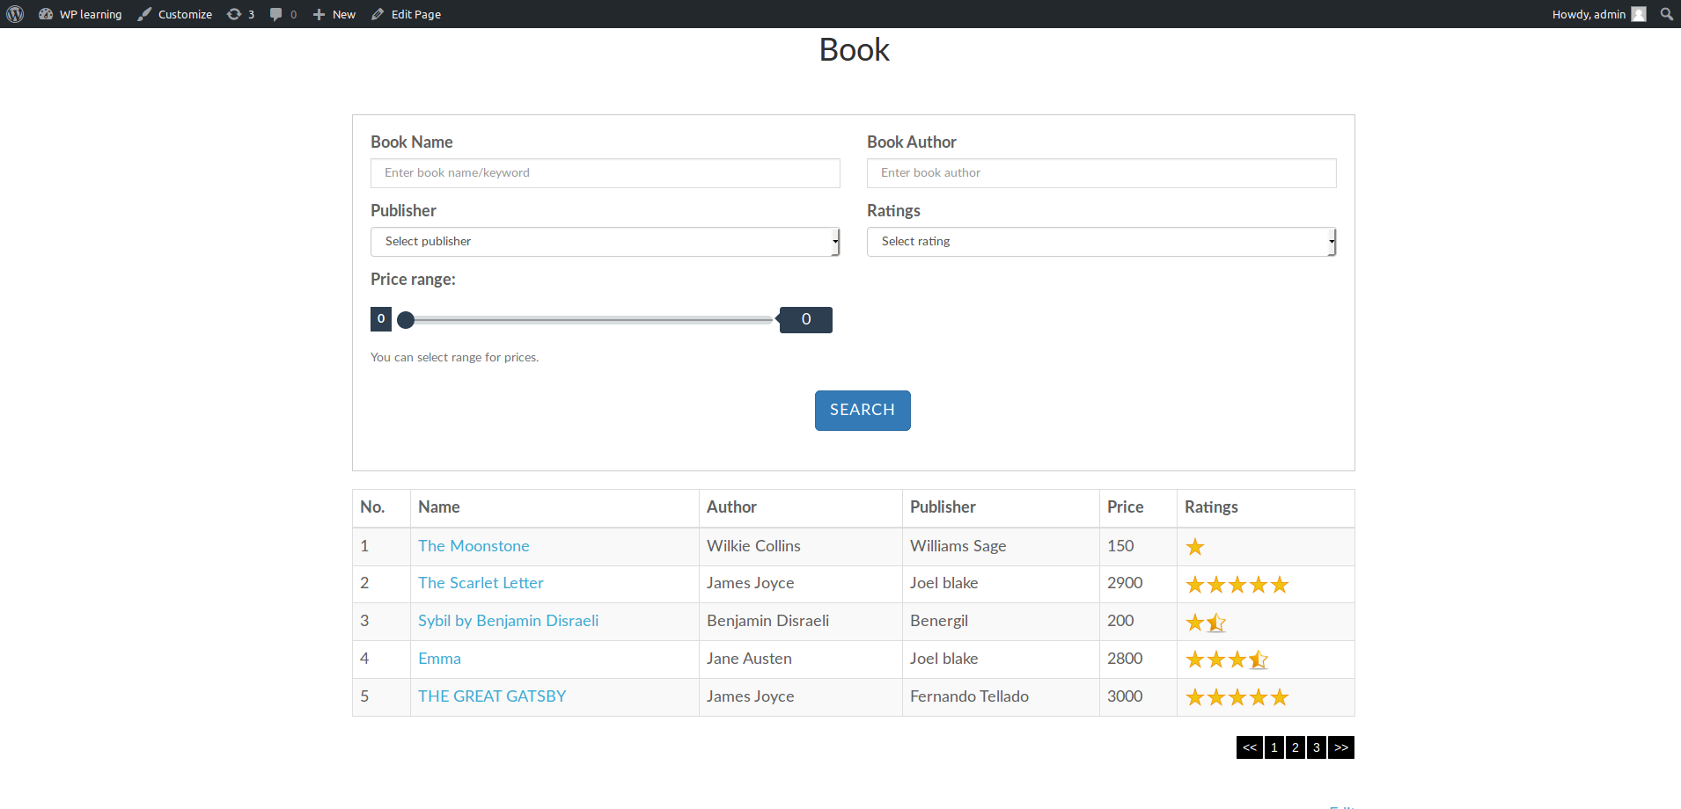

5) WP Ajax searching on the front end:

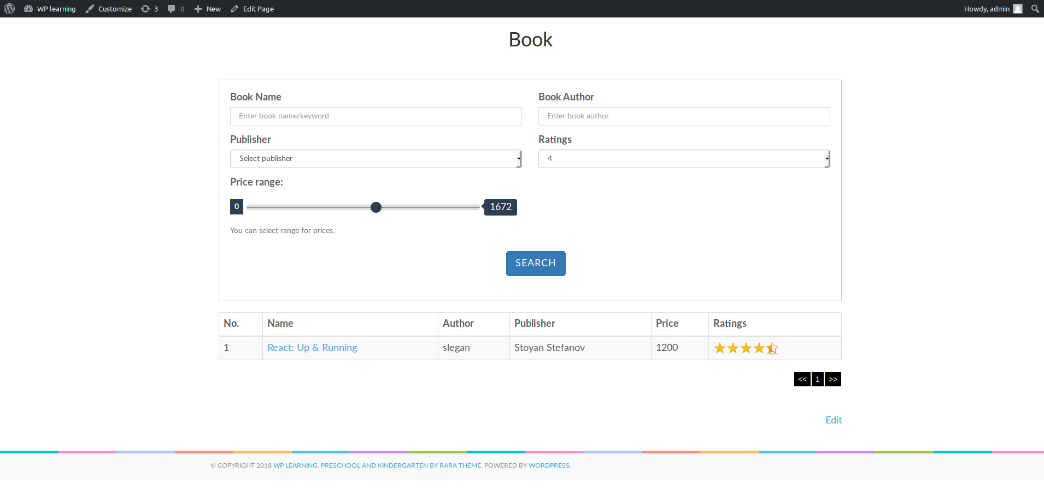

6) Single Post Page:

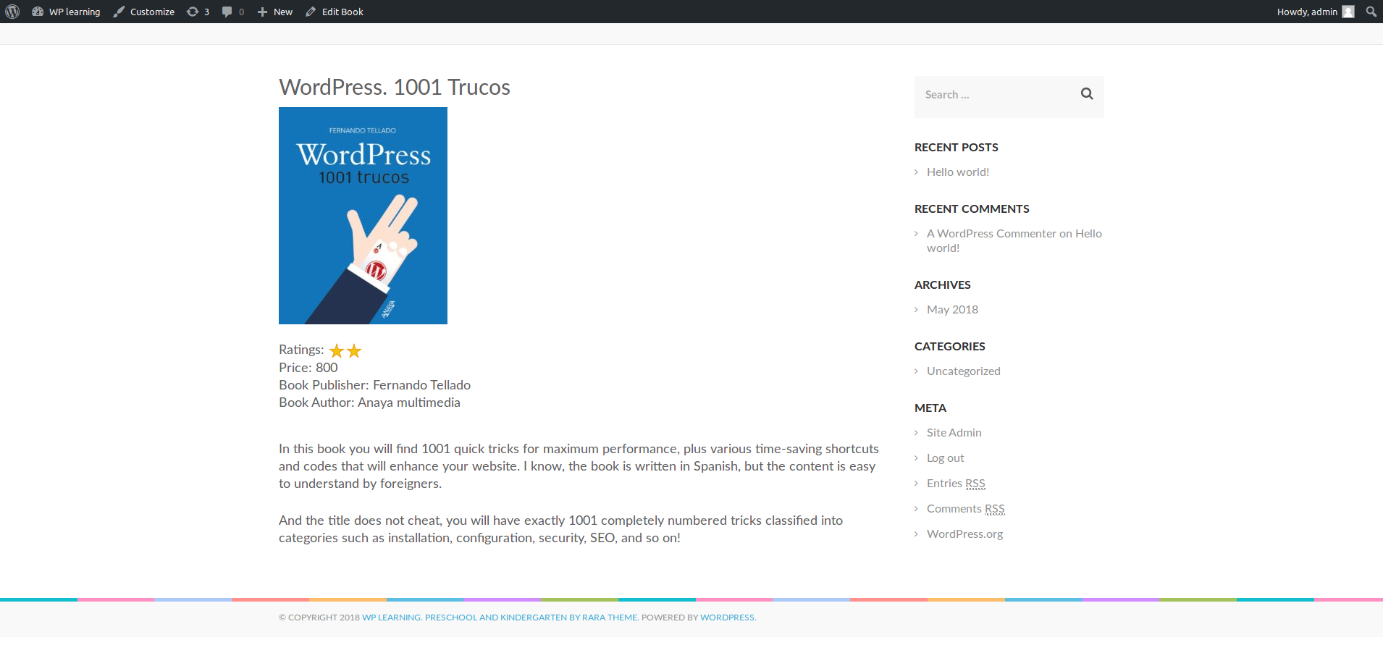

I have listed all the data for book post type by using custom single-book.php in plugin.

Plugin Demo on one of our development server:

Please check and let me know if you have any questions.

Thank you!